IIS Configuration for ARMNotificationHub

The ARMNotificationHub is a .NET Core application, part of ARM services which will handle notification delivery to web clients. SignalR push notifications are enabled now as part of ARMNotificationHub.
Prerequisites to be installed
- .NET Core Hosting Bundle (.net core 8.0).
- .NET Core Runtime (.net core 8.0).
- Redis

Application Pool Configuration
The Application Pool must be configured with following settings.
Basic Settings
Setting | Value | Reason
.NET CLR Version | No Managed Code | .NET Core runs its own runtime; IIS handles the request routing only.
Managed Pipeline Mode | Integrated | Standard for modern .NET hosting.

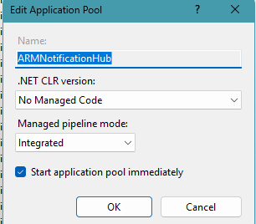

Advanced Settings
To access these, right-click the App Pool > Advanced Settings.
- Process Model
  - Maximum Worker Processes: 1
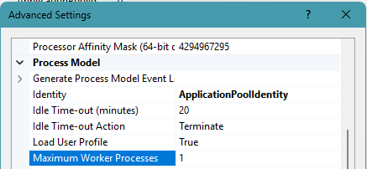
- Recycling
  - Specific Times: Eg. 12:00 AM, 5:00 AM or local off-peak hours.
  - Disable frequent recycling.
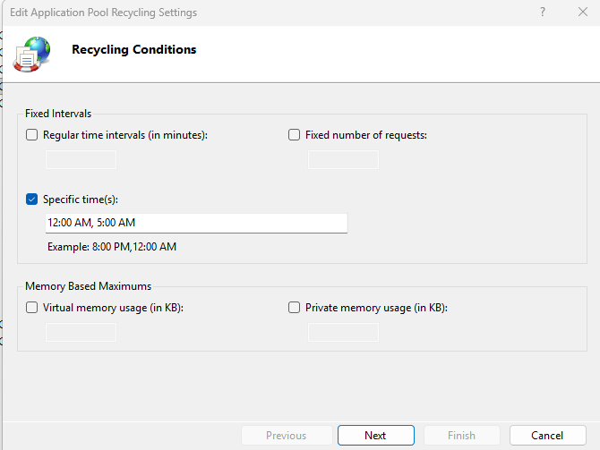
Configuring ARMNotificationHub URL in Axpert Admin page:
- Configure Notification URL in Axpert admin page for each application.
- Configure Notification Expiry Hours in Axpert admin page for each application.
- Configure Notification Max Per User in Axpert admin page for each application.
- 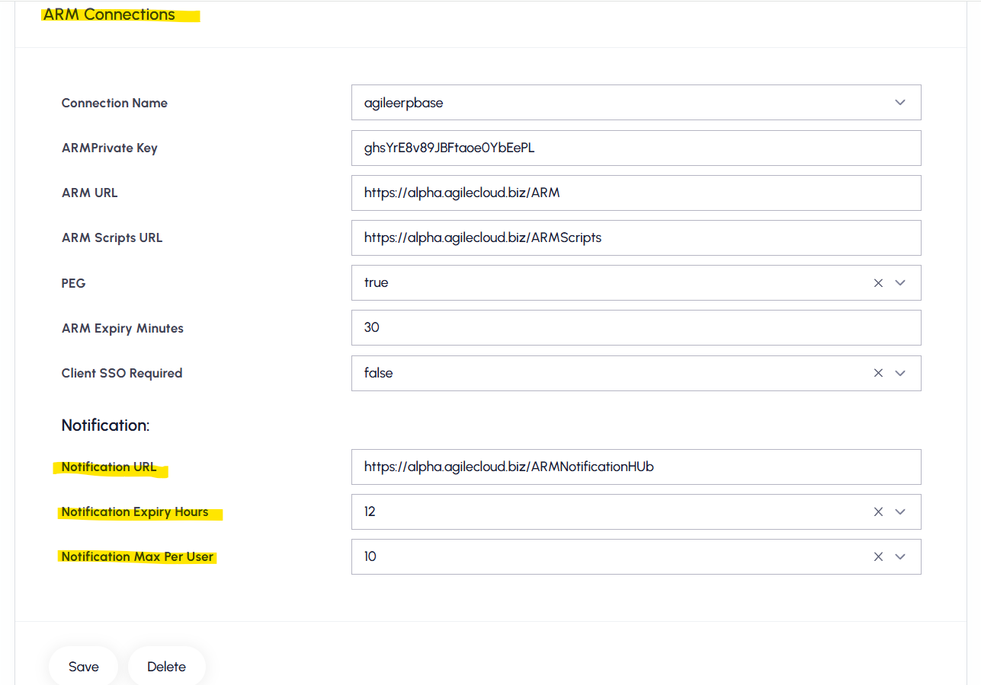
Appsettings.ini file config:
- Latest appsettings.ini file from axpertwebscripts should be maintained in the ARMNotificationHub application.

Validating ARMNotificationHub site status:
- Run the following URL “<ARMNotificationHub URL>/api/v1/ armappstatus” in browser to check the application running status. Should get following response in :
  - Application is running successfully
